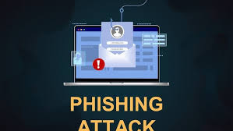

Introduction
Phishing is a type of cyber attack in which attackers attempt to steal sensitive information such as usernames, passwords, and banking details by pretending to be a trusted entity. These attacks commonly occur through emails, messages, or fake websites. Phishing is dangerous because it exploits human emotions like fear and urgency, making users act without proper verification

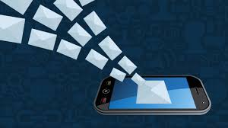

Sample Phishing Email
From: alerts@hbl-secure-support.com
Dear Customer,
We have detected unusual activity on your account. For your protection, your account has been temporarily restricted.
Please verify your identity immediately by clicking the secure link below:
http://hbl-secure-support.com/verify⁠�
If you do not verify your account within 12 hours, it will be permanently blocked.
Regards,
HBL Security Team

t

Suspicious Elements
The following suspicious elements are identified in the email:
The sender’s email address appears unofficial and not from a verified domain
The link provided is not secure (uses HTTP instead of HTTPS)
Use of urgent language such as “immediately” and “12 hours”
Threat of permanent account blocking
Generic greeting (“Dear Customer”) instead of the user’s name

2. Sample Phishing Email
From: alerts@hbl-secure-support.com
Dear customer

http://hbl-secure-support.com/verify⁠

If you do not verify your account within 12 hours, it will be permanently blocked.

Regards,
HBL Security Team

Red Flags
This email contains several phishing red flags:
Urgency Pressure: Forces the user to act quickly
Authority Impersonation: Pretends to be a bank
Fear Tactics: Threatens account suspension
Suspicious Link: Redirects to a fake website
Lack of Personalization: No specific user details included

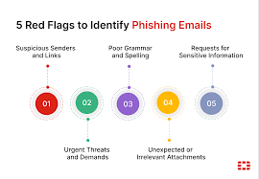

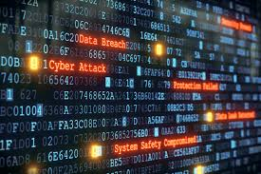
Why This Email is Unsafe
This email is unsafe because it is designed to trick the user into clicking a malicious link and entering sensitive information. The attacker uses social engineering techniques such as urgency and fear to manipulate the victim. If the user provides their details, it can result in account compromise and financial loss.

Types of Phishing Attack

Emails: The most common way of starting a Phishing Attack
Email is the most common type of threat vector, and 23% of people click on malicious emails. It only takes one click for your whole network to be compromised which is why it has become the cybercriminals favorite weapon.
91% of cyber attacks start with an email and as a business it is important to be aware of the different types of phishing emails cyber criminals use to target organizations. In today’s digital age, where information is power, phishing attacks continue to pose a significant threat to individuals and organizations alike.

Spear phishing Clone phishing Vashing Whaling
Business email compromise Snowshoeing

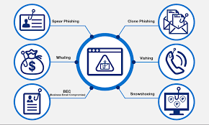

Safety Measures
To protect against phishing attacks, users should:
Avoid clicking on unknown or suspicious links
Verify the sender’s email address carefully
Check for secure websites (HTTPS)
Never share personal or banking information via email
Report suspicious emails to the relevant authority

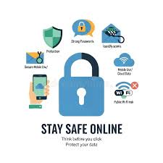
Conclusion
Phishing attacks are becoming increasingly sophisticated and can cause serious financial and data loss. Users must remain cautious and follow security best practices. Awareness and careful verification are the most effective defenses against phishing attacks.

